**Chap 2: Asset Classes, Financial Instruments**

**Bid = YOU SELL, Ask = YOU BUY**

**Treasury Bills (T-Bills):**

**Popular Yield Measurements**

Po = Discount Price

Pf = Par/ Face Value

* Bank Discount Rate idy = ,
* Ask-Yield [bey: Bond Equivalent Yield, spy: single pmt yield]

* Effective Annual Return, EAR=

single pmt to EAR=

Notes (<=10 years) & Bonds (10-30 years)

**Treasury Inflation Protected Securities (TIPS, i):**

.

**MBS 🡪 CMO tranches 🡪 CDO tranches**

MBS: free up capital; pool diversify indv mort risk; charge fees for being intermediaries for MBS

Tranches: responding to DD from II for inv of diff rating; safest tranche highest rating sell safest at higher price eg. pension f; riskiest lower price eg. hedge f; satisfies risk level of different clienteles with CDO & charge diff price

**Types of Indexes (Base of Derivatives)**

**Market-value weighted**: (STI, S&P) Most common. Invest amt proportionate to market value / cap of each stock. Favour large coy weight based on market cap (invest proportional to Mkt Val)

**Index (t=1) =**

**Chapter 3 Securities Markets**

**Types of Orders:** Market Order| Limit Buy Order (buy low sell high)| Stop Loss/Buy Order (minimise loss/riding wave)

**Total trading cost = commission + spread/2**

**Margin Trading:** Borrowing money to purchase stock.

* **Initial Margin Requirement (IMR)**   
  = min % of initial investor equity (IIE)
* **Maintenance Margin Requirement (MMR)** = min % **Equity/MV** b4 must top up to IIE
* MV = number of stocks x price of each stock
* **Margin = Equity in Account / Value of Stock**
* **Margin call** occurs when:

**Buy**: MV = Borrowed / (1 - MMR), where equity = MV – Borrowed;

**Short**: new MV = TMA / (MMR + 1), where TMA = Equity Account + original MV

* **Amount to top-up** = Margin required – Current Equity
* **Short sell Topping up = Necessary Equity – Current Equity**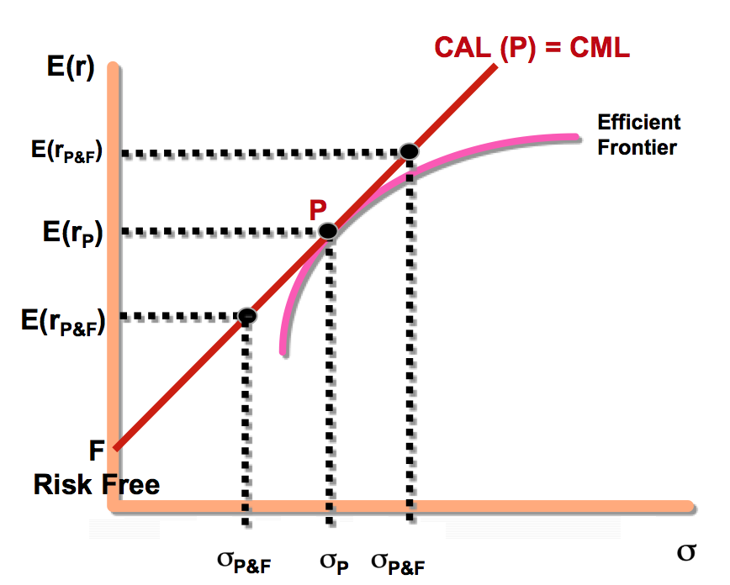 ; Current Equity = Initial TMA – current MV
* Rate=
* **Zero Uptick, Uptick Rule:** Cannot SS on down trend.
* **Round Trip = A Purchase + A Sale**
* Long Position (Bullish): Make money if prices increase
* Short Position (Bearish): Make money if prices decrease

**Chapter 5 – Risk and Returns**

**Measures for the Rate of Returns**

* **Holding Period Returns (HPR)** = (Pt + Dt - Pt-1) / Pt-1
* **Arithmetic Average Return =** sum of quarterly returns / no. of quarters
* **Geometric Average Return (GAR)**

= [(1 + HPR1)(1 + HPR2)...(1 + HPRn)]1/n -1

Used if interim CFs or returns are volatile

**Risk & Risk Premiums**

Scenario Expected Variance (Probability)



Expost (after the event) Expected Variance (Actual)

Ex-post standard deviation = risk







**Value at risk= E(r)+ (-k) (std dev) where k=1,2,3**

**Real VS Nominal Rates (Fisher Effect)**

* Approximation:
* Exact:

**Complete Portfolio:** Entire portfolio including risky and risk-free assets, Depicted by CAL, varying “y” moves along CAL. Y is determined by risk aversion.

**Leverage:** 50%,y=1.5;

* **Risk Aversion,**

A>0: Risk adverse; A=0: Risk neutral; A<0: Risk loving (unrealistic)

E(rp) = Expected return on portfolio p

rf = the risk free rate y= %in risky asset

A x σp2 = Proportional risk premium



 :RP

Higher A, More Risk Adverse, Higher Risk Premium

Risk-neutral investors: only focuses on E(r) > rf

**Chapter 6 – Efficient Diversification**

**Average Principle:** Firm-unique risk is diversified away

* Variance of a **2 Stock** Portfolio:



**3-stock**: s2p = W12s12+ W22s22+ W32s32+2W1W2Cov(r1r2) +2W1W3Cov(r1r3) +2W2W3Cov(r2r3)

* **Covariance:** Direction

=average or expected return for stock 1

* **Correlation Coefficient** (): Direction & Degree

-1.0 to +1.0 (perfectly negatively to positively correlated)

**Efficient Frontier:** Risky portfolios with highest E(r)

for that same level of standard deviation

**Capital Market Line (CML)**: donimates EF;

CML gives highest Sharpe ratio on all points of EF except tangency portfolio; E(r) higher on CML than EF for each risk level

CML can only happen with a risk free asset

**Optimal Risky Portfolio (P)/Market Portfolio: Tangency Portfolio** on efficient frontier that connects the risk-free rate

**Systematic Risk/ Market risk (β):** Arises from events that affect the entire economy ≠ volatility

**Unsystematic Risk/Idiosyncratic Risk** = Firm Specific risk

**Single Factor Index Model**

**Actual Return = Expected Return**

**Ri**== actual excess return| = average return not explained by **β** & market risk premium | = Sensitivity of a security’s excess return to the systematic factor | **Rm**= =Excess return of systematic factor| =Unanticipated firm-specific events(idiosyncratic)

**Variance (**

**βiRm**=variation in Ri explained by systematic risk

**ei** = variation in Ri due to idiosyncratic risk (from point on line to dot)

**α** = average return not explained by **βi** and market risk premium (from x-axis to point on line)

Securities Characteristic Line

α = y intercept, ß = Slope, ei = scatter

Total risk = systematic risk + firm specific risk

Systematic Risk;Total Risk

R2: 0 to 1 none to all variation explained by market

**Negative β**: Hedging Instru, will have lower rate of return

**Steepest Slope:** Highest Systematic Risk

**Dots Closest to Line:** Lowest Idiosyncratic Risk

**Intercept below ZERO:** Unattractive Stock

**Chapter 7 – CAPM , Arbitrage Pricing Theory**

**Capital Asset Pricing Model (CAPM)**

Assumptions: (a)Individual investors are price takers (b) Single-period investment horizon (c) Investments are limited to traded financial assets (d) No taxes and no transaction costs (e)Information is costless and available to all investors (f) Investors are rational mean-variance optimizers (g) Homogeneous expectations (no inside information)

**🡪 investors hold combi of mkt portf & rf dpding on risk aversion**

**steepest grad of SML = CAPM:** **E(ri) = rrf + βi[E(rM) - rrf]**

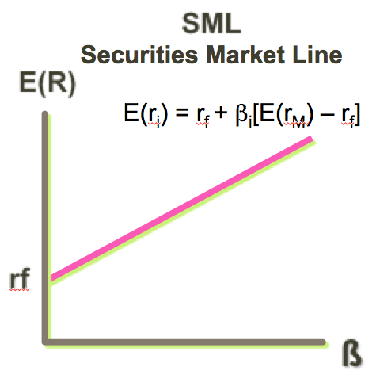

**Gradient:**

(For Market)

if CAPM holds: - all stock should be on SML

- all stock have same risk-return trade-off

If CAPM holds, only ONE (systematic) risk, β, matters in determining the risk premium & hence E(r)

Risk Premium of Individual Securities: Proportion to

From**,**

**β**: Function of the covariance of stock’s return with market portfolio’s return

sensitivity of security’s return to systematic factor

(therefore market portfolio has beta of 1)

Beta > 1 greater senstitivy; <1 below-average sensivity

**α: risk- adjusted excess return =** Actual return – CAPM’s E(r) ; if CAPM holds, α=0 🡪 all stocks on SML

**Multi-Factor Models:** Used when security returns responds to several systematic factors.

**Fama-French 3 Factor Model,**

HML (**High – Low** book to market ratio**)**, SMB (**Small – Big** firms)

**Arbitrage Pricing Theory**: Exploiting the mispricing of 2 or more securities to achieve risk-free profits.

(CAPM says all securities are on 1 line, M. Therefore, prove that **[i] gradients are different, thus have mispriced. OR [ii] Expected Return ≠ Actual Return**

Then, calculate overall alpha for abnormal returns on riskless portfolio. **Long the larger one**

**Factor Portfolio:** well-diversified portfolio with (1) related to one risk factor (2) related toother risk factors

APT assumes: investors form well-diversified portfolio, zero arbitrage opp, no taxes & transaction costs.

**APT:**

**Multifactor APT:**

**Creating Arbitrage Portfolio**:

1) Prove (i) or (ii). Construct Arbitrage Portfolio: Find so that

2) Compare Arbitrage Portfolio & Original Portfolio

- short sell one and buy the other such that original investment = 0

- arb portfolio: buy/short the risk factor(s), then top up with rf rate

3) Profit next period: diff b/w arb E(r) and calculated E(r)

Rules of arbitrage: (if not, arbitrage opp exist)

Arb Portfolio is Risk-Free (No systematic & unsytematic risk) Except when fails to account for liquidity risk of small cap stocks.

* Alpha of a portfolio:
* **Chapter 8 Efficient Market Hypothesis**

- cannot CONSISTENTLY generate ABNORMAL returns

* **Random Walk**: when stock price random & unpredictable

(Info. Efficiency) Prices on positive trend (infl & RP)

* **Weak Form:** prices reflect historical data
* **Semi Strong Form**: prices reflect all publicly avail info
* **Strong Form**: prices reflect all private and public info

**Active Mgt:** Assumes market inefficiency

**Passive Mgt:** Consistent with EMH; assumes semi-st eff

**TEST FOR WEAK**

**Technical Analysis:** Assume prices follow predictable trend. Only inefficient market. Info of underlying asset irrelevant.

🡪 use pattern to earn abnormal returns: weak form violated

**Momentum Effect:** tendency of poorly performing and well-performing stocks in 1 period to continue that abnormal perf in the following periods. *(Returns over long horizons- opp)*

**Security Analysis, Testing of Trading Rule**

**TEST FOR SEMI-STRONG**

**Fundamental Analysis:** Identify mispriced securities based on analysis of firm’s financial statements and future prospects.

**Event Study:** Examine how quickly information is integrated into prices around an informational event, **Investment News**

**TEST FOR STRONG**

**Historical α, Timing Strategies, Performance of Managers**

**How to Determine if Returns are Abnormal**

**Market Model Approach**

Estimate a and b coefficients

Abnormal Returns, ARt = et = ractual – [a + b(rindex,t)]

**Issues for EMH (explain why earn abnormal returns)**

-Magnitude Issue – small changes in perf cannot be measured

-Selection Bias – good selection techniques will be secret

-Lucky Event Issue – managers outperform due to chance

# -Model Misspecification – Wrong Model Used Chapter 4: Mutual Funds

Price at end of day (non-continuous -> uncertainty)

Active and Passive Fund (Seek Alpha v Benchmark)

* **Price per share/ NAV** = (Market value of assets – liabilities) / shares outstanding at end of day
* **Rate of return** = (NAV1 - NAV0 + income & capital distribution) / NAV0
* **Operating expense/other fees such as 12b-1 charges** - Operating expenses: expense ratio of NAV. Other fees: Distributn costs paid by fund, ad cost, alternative to load.

**AV x (1 – 12b-1) = NAV**

* **Front-end load** – commission charged as % of offering price, deducted to arrive at NAV (charged at beginning).

P - PFEload=NAV or **(1-FEL) x P = NAV**

* **Back-end load** – commission charged as % of withdrawal price. (charged at ending) 🡪 does not affect NAV!
* **Impact of cost on investment performance:**

{10000(1-FEL)[(1+return)(1-expense)]^n} (1-BEL)

**Chap 18 : Portfolio Performance Evaluation**

**General Methodologies for Performance Evaluation**

**Peer Group:** Compare w competitor within a category

**Benchmark Portfolio:** Compare with a passive index.

**Risk Model:** Estimate risk-to-reward measures (as below)

* **Jenson’s α** **= (rp-rf)-βp(rm-rf)**

Based on actual performance index (realised α) instead of expected market index (CAPM’s α)

* **Multi:**
* **Total excess return** = Rp - Rm = α
* **Factors leading to Abnormal Performance**

-Successful allocation across broad asset class / within each asset class/ individual security selection

* **Mutual fund performance**: if skills are random & no expenses, 50% of funds outperform benchmark. If markets are efficient, the avg mutual fund before expenses has α=0 & β=1 (similar to market benchmark). After expenses, funds underperform benchmark. If better off with actively managed portfolios, markets are NOT semi-strong form efficient, can identify fund managers that outperform benchmark after expenses.
* **NOTE**: small market cap stocks have higher beta

The **size premium** is the historical tendency for the stocks of firms with smaller market cap to outperform the stocks of firms with larger market capitalizations.

**Entire-Wealth Portfolio:** Choose 1 portfolio & cant diversify across funds. Potentially under diversifying, total risk matters. Use highest **sharpe ratio**: (E(rp)-rf) / σp When choosing optimal risky portfolio

**Fund of Funds:** choose >1 funds, a piece of a larger port.

**Treynor ratio** = (rp – rf) / βp - residual risk ignored as diversified away, so focus on **β** to SELECT fund(s)

* portfolio is a part of a larger portfolio with several fund mgers (*to rank portfolios* to be mixed to form Optimal Risky Portfolio) diversified before and after. **Treynor Ratio**: Compare average excess return to non-diversifiable or systematic risk. Why not Sharpe? There is no idiosyncratic risk on diversified funds so focus on systematic risk = use Beta to compare systematic risk

**Adding an Active Portfolio to a Passive Portfolio**

Delivers the benefit of α but increase diversifiable risk

**Information Ratio**: **(αp) / σ(ep)** per unit of unsystematic/diversifiable risk

Achieve the best CAL with the highest slope

**σ(ep):** std dev of residual returns from an index model, the difference between Rp and Rm ≠ σ(Rp)

**Soptimal of combined portfolio**=

Fully diversified before. Might not be so after (taking idiosyncratic risk). Often used to evaluate hedge funds, which follows Market neutral strategy: beta=0, alpha > 0

|  |  |  |  |
| --- | --- | --- | --- |
| Before investing | Peformance Measure | Application | After investing |
| UnD | Sharpe  Rp/ σp | Select 1 Fund: for use as optimal risky portfolio | unD or D |
| D | Treynor  Rp/ β | Fund of Funds: for selecting fund(s) to mix with many other portfolios | D |
| D | Information ratio  (αp) / σ(ep) | Add to benchmark: for adding an active fund to an existing passive benchmark | unD |

But for ***COMPLETE*** portfolio, we always use **Sharpe** to measure regardless of performance measure.

**Chap 10: Bond Prices & YTM**

+

**Bond Price** =

= Coupon X Annuity factor + Par X PV factor

**Invoice Price** = Quoted Price + Accrued Interest

**Accrued Interest** =

**Current Yield** = Coupon/Price

**YTM** = Current Yield + Capital Gain Yield

**YTCall**: call price replaces par; call date replaces maturity

**Holding Period Return (HPR)**

1)Find Bond Price at t=0 and t=t. Differnc = Capital Gain

2) Find Future value of all coupons to be reinvested at market rates.

3) Find the return.

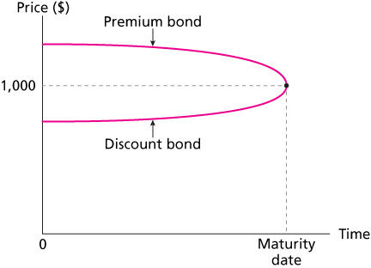4) Convert to annual rate =

**Premium: Coupon>YTM, Price>Par**

**Discount: Coupon<YTM, Price<Par**

**Par Bond: Coupon = YTM, Price = Par**

**Yield Curve (Term Structure)**

**Determinants of bond credit rating:**

* Coverage ratio: times interest earned ratio
* Leverage ratio: debt to equity ratio
* Liquidity ratio: current ratio; quick ratio
* Profitability ratio: ROA, ROE
* Cash flow-to-debt ratio

↓ in default risk 🡪 ↑ bond price 🡪 ↓ YTM

**Expectation:** LT rates a function of expted future ST rates

Forward Rate :

n: implied one year f rate for the (n)nd year

**Liquidity Preference**: N↑, YTM↑ (always upwards)

**Chap 11: Managing Bond Portfolios**

**Factors to I/R sensitivity**

1) I/R (yields) ↑, Bond Price↓

2) ↑YTM, Price↓ abit, ↓YTM, Price↑more

3) LT Bond more price sensitive than ST bond

4) Sensitivity of (Bond Prices to Changes in Yields) increase at a decreasing rate as maturity increases

5) Coupon high, Price Sensitivity Low

6) Sensitivity of (a bond’s price to a change in its yield) inversely related to YTM at which the bond is currently selling. (YTM 🡪 Denominator)

maturity is major determinant of sensitivity of bond price to i/r changes, but coupon and ytm also major determinants

**Duration (Effective Maturity)**

|  |  |  |  |  |
| --- | --- | --- | --- | --- |
| ***Year (t)*** | ***Cashflow*** | ***PV@YTM*** | ***PV/Price (Wt)*** | ***(PV/Price)*T*** |

Long Maturity, Low Coupon, Low YTM & i/r 🡪 Longer Duration; Duration = maturity for zero coupon bond

(gives coupon forever but no principal pmt)

Price ∆ proportional to duration

i/r risk: price risk (can’t sell at expected high price as i/r ↑); reinvestment risk (can’t reinvest coupon at promised yield rate 🡪 ↓ i/r ↓ FV of reinvested coupon)

**Convexity:** Duration is approximation, underestimates ↑ in bond price when YTM ↓ and vice versa for overestimate

🡪 Convexity ↑ price increases and ↓ price drops

Convexity =

Choose the bond with greater convexity 🡪 ↑ desirable

*Basis Point: one hundredth of one percentage point*

**Chapter 15: Options Market Call = Buy, Put = Sell**

If stock split, adjust accordingly.

**European:** exercised only on expiry date, **American:** exercised any day before or on expiration date

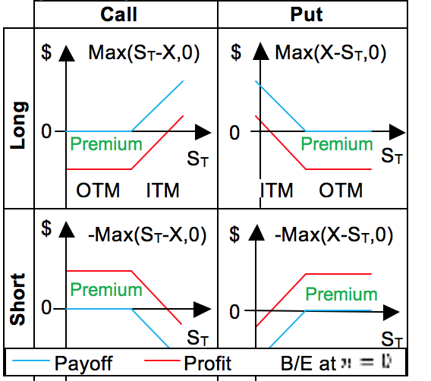

**Protective Put**

Long stock long put option; Similar profile to long call opt

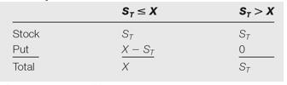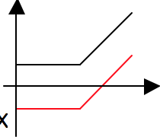Min profit: X – (S0+P) Max Profit: unlimited

X

X – S0 + P

**Covered Call Strategy**

Long stock write call option; Similar profile to short put

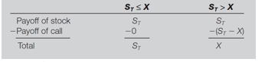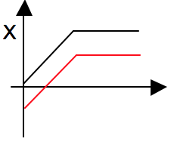**Min Profit: -S0+C, Max: X-S0+C**

- (S0 – C)

**Put-Call Parity**

Long call short (write) call option

Cost of Portfolio **= C-P =** **S0 – Xe-rT**

Exponential: assume continuous compounding (instant)

T: in fraction of the year to expiration (6months =1/2)

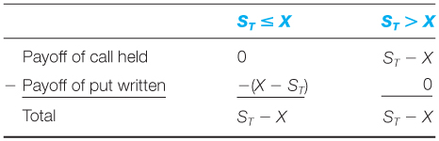R: risk free rate of return (usually annualised)

***Payout same if not arbitrage opp.***

Given: C – P > S0 – Xe-rT, arbitrage opp. Short more exp portfolio (C-P), long cheaper portfolio (S0 – Xe-rT)

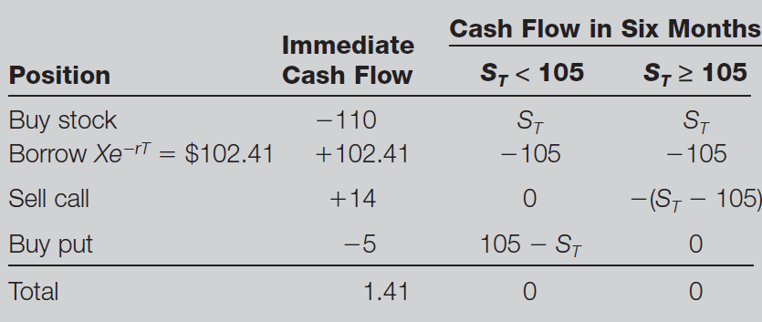

**Chapter 16: Option Valuation**

|  |  |  |
| --- | --- | --- |
| **↑ in Variable** | **Call Option** | **Put Option** |
| Stock price, S | Increase | Decrease |
| Strike price, X | Decrease | Increase |
| Volatility, *𝜎* | Increase | Increase |
| Time to exp, T | Increase | Increase* |
| Risk free i/r, rf | Increase | Decrease |
| Div payouts, *𝛿* | Decrease | Increase |

**Binomial Call Option Pricing**

1. Determine Hedge ratio, **H=**

2. Form rf Hedge Portfolio: buy H shares, short 1 call;

Find rf payout in the future for up and down (which equals)

3. Pay Now = PV of payout in future

**Price now– C = Payout / (1+r)** 🡪 4. Find C

Value of portfolio today, **V0 = *H*\*S0 – C**

Payout: Value of portoflio at expiration if up**, Vu =*H*\*u*S0 - Cu** = Value at expiration down, **Vd = *H*\*d*S0 - Cd**

**Shortcut:** where

**Black-Sholes Option Valuation**



*N(D) = standard normal probability function (shaded area to left of normal curve)*

Implied volatility is implied by the market price of the option (what market expects volatility to be) 🡪 powerful forecast if market efficient